**ARTIFICIAL INTELLIGENCE FUNDAMENTALS**

**Abstract**

The current project deals with the aspect of customer satisfaction in electronic commerce through the use of an e-commerce platform named Shopzilla, with the data set of customer interactions and ratings across various products for one month taken into consideration. The dataset is smooth with different features that come along with interaction channels, product categories, agent names and customer reviews which are scored on the CSAT. The project uses a stuctured approach which involves data preprocessing, descriptive analytics i.e. EDA and the deployment of different machine learning models.

Data preprocessing encompasses dealing with missing values as well as encoding of categorical ones in order to obtain the dataset ready for analysis. EDA leans on visualizations like box plots, pie charts, histograms, and sunburst charts as well for the purpose of unbling the interface of trends like CSAT scores by channel, tenure, category, or a subcategory. Through these visualization, it is possible to see what is going up, what is going down or what stoops and hooks the data together, which is rich information to see why the customer values the service.

The ideas of Machine learning models can be applied to predict customer experience. The Decision Tree classifier is trained to classify CX back in crowdsourcing via various features while the Convolution Neural Network (CNN) regression model is the one that is being developed to directly predict the CX back in crowdsourcing. Models performance is of primary concern, therefore metrics like a confusion matrix, and accuracy score, classification report, and model loss are used to evaluate the effectiveness of the models.

The total assesment provides an overall assessment on customer satisfaction dynamics in e-commerce industry with both customers’ experience and service strategies are considered, by utilizing the traditional machine learning as well as deep learning techniques to obtain actionable insights that the company can use to improve the customer service processes at Shopzilla.

Table of Contents

Introduction 4

Background 4

Aim and objectives 5

Dataset description 6

Problem statement 9

Machine learning models 9

Summary of the approach 9

Decision tree 10

Convoluted neural network 10

Data analysis and visualization 11

EDA 11

Data visualization 13

Model training, testing, and evaluation 16

Result and discussion 18

Ethical discussion 21

Data collection and privacy 21

Model development 21

Conclusion, recommendation, and future work 21

References 23

# 

# Introduction

The importance of customer satisfaction in e-commerce is a paramount factor, as it represents a critical dimension that often determines the business’s success and survival. Nowadays, with the emergence of online stores, customers want to be serviced in a spectacular manner to not to be lost to the competitors and since the brands they buy from become their center of devotion (Raffort *et al.* 2020). The customer satisfaction is a complex process and it is key to implement big data analysis, predictive modeling and actionable data based on in-field market studies.

This research probes into the area of e-commerce customers' attitude of satisfaction, conceptualizing the Shopzilla- a made up e-commerce site. The data collection object analyzes the monthly detail of the users aggregates with the business tech support saying on one side and the other consists of interaction channels, agent information, as well as corresponding Customer Satisfaction (CSAT) score. Delving into the dataset and employing high-end analytical designing methodologies, the initiatives aims at dissecting the key elements of customer satisfaction and providing strategic interventions to increase service quality.

Pre-processing data, exploratory data analysis as well as of building the predictive models, our project company will provide Shopzilla stakeholders with appropriate insights needed to redesign their customer service strategies and boost customer-oriented culture (Thakur and Konde 2021). Through such initiative this project will add to the ongoing growth of e-commerce analytics field, drawing a full-sided picture of consumer sentiments, and thus providing managers with data-backed business decisions in the relevant sphere.

## Background

It is the customer satisfaction drive that becomes the hallmark feature of e-commerce that can determine the success or failure of e-commerce enterprises within a dynamic and cut-throat competitive market. The rise of e-commerce, now, customers are more tech-savvy than ever before. It's no good to go online only improving on your products and services but without investing in the tips to win customers' hearts and mind. On this stretch of highway, Shopzilla, a hidden novelty e-commerce project, aims to detect customers' satisfaction and optimize it by using data for analytics and predictive modeling (Hoshimovna *et al.* 2023).

This project takes a dataset which gives an imaginary one-month period in aspire shopping's 24/7 customer support. This dataset contains a number of features and attributes among which interaction channels, agent status, as well as remarks are captured correlated to customer satisfaction that can be referred as CSAT. Exploiting this dataset, the project strives to deconstruct the complexities of customer satisfaction micromaintained and to develop forecasting models that are able to accurately forecast CSAT scores.

In pursuit of this objective, two distinct modeling approaches are implemented a Decision Tree classifier and a CNN regression model for these tasks was employed. Decision Tree classifier is the preferred choice for its interpretability as well as for assigning outcomes depending up on unique set of features chosen for the task. On the other hand, CNN Regression mode is selected for its capability to capture the intrinsic and complex relationships of the given data and to forecast the CSAT scores.

Employing these modeling mechanisms is the project’s aim to help Shopzilla derive operative guidance on what things influence customer satisfaction the most and thus the site’s management offices should be equipped with the right modelling tools (Wang *et al.* 2022). The project is conducted by way of rigorous data preprocessing techniques, exploratory data analysis, and model implementation, so as to channel business development directions that are likely to stimulate the increase in customer satisfaction and drive sustainable growth for Shopzilla in the ultracompetitive e-commerce market.

Shopzilla, with its face automatically changed to fit customer expectations and changing market forces, this project is a direct result of Shopzilla's deep customer-centricity, and data-driven innovation. Through the exploitation of advanced analytics and machine learning Shopzilla is aiming at not only to reach.

## Aim and objectives

**Aim**

The aim of this study is to measure the level of customer satisfaction of a online services on a Shopzilla shopping platform by using descriptive analytics and predictive modeling.

**Objectives**

* To analyze the dataset comprehensively, identifying key features and patterns that correlate with customer satisfaction levels.
* To develop and train machine learning models capable of accurately predicting customer satisfaction scores based on input variables.
* To evaluate the performance of the developed models using appropriate metrics such as accuracy, precision, recall, and F1-score.
* To identify actionable insights from the model predictions and data analysis, providing recommendations for improving customer service strategies.

# Dataset description

Secondary dataset has been used in this project and the data enables consumer judgment statistics for a period of one month through a virtual shopping center called Shopzilla (a fake name). Along the line it incorporates the same details that include category and type of communication, customer ratings, profiling of agents, feedback response date, category or item price, and the manager's name, along with CSAT score.

Dataset link: <https://www.kaggle.com/datasets/ddosad/ecommerce-customer-service-satisfaction/data>

All together, it includes a list of carefully selected attributes that provide several perspectives on customer service encouters and their levels of satisfaction. The dataset includes the following attributes:The dataset includes the following attributes:

* Unique ID: A unique identifier assigned to each customer interaction record.
* Channel Name: The communication channel through which the interaction took place, such as inbound calls, outbound calls, or emails.
* Category: The broad category to which the interaction pertains, such as product queries, order-related inquiries, or returns.
* Sub-category: A more specific classification within the category, providing additional context to the nature of the interaction.
* Customer Remarks: Any remarks or comments provided by the customer during the interaction.
* Order ID: The unique identifier associated with the customer's order, if applicable.
* Order Date Time: The date and time when the order was placed.
* Issue Reported At: The timestamp indicating when the issue was reported.
* Issue Responded At: The timestamp indicating when the issue was responded to by the customer service agent.
* Survey Response Date: The date when the customer responded to the satisfaction survey, if applicable.
* Customer City: The city of residence of the customer.
* Product Category: The category of the product or service related to the interaction.
* Item Price: The price of the item or service involved in the interaction.
* Agent Name: The name of the customer service agent handling the interaction.
* Supervisor: The supervisor overseeing the work of the agent.
* Manager: The manager responsible for the team or department.
* Tenure Bucket: The tenure category of the agent, categorized based on their length of service.
* Agent Shift: The shift during which the agent was working when the interaction occurred.
* CSAT Score: The Customer Satisfaction (CSAT) score provided by the customer in response to the satisfaction survey, if available.

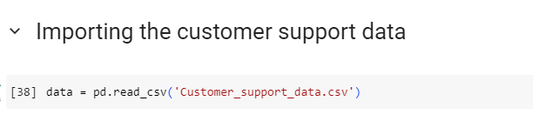

**Figure 1: Loading the customer support dataset**

(Source: Created and observed using Google Colab)

This line opens the csv file 'Customer_support_data.csv' and stores the data in a pandas DataFrame named data. Through establishing the pd.read_csv() function, the CSV file is read into the DataFrame.

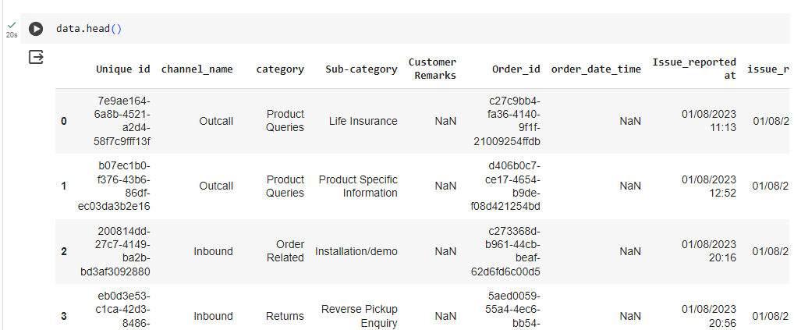

**Figure 2: First few rows of the dataset**

(Source: Created and observed using Google Colab)

First few columns of the dataset has been printed using the head code and represented through the above pictorial representation. Using the above code the first few upper columns has been shown.

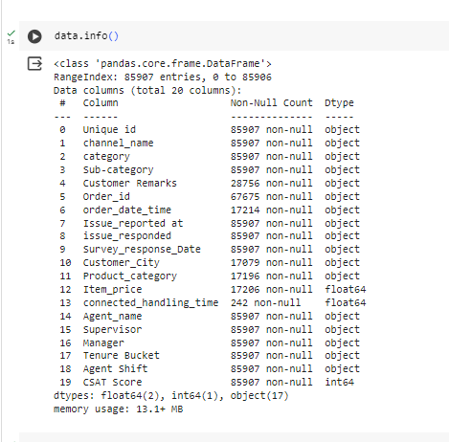

**Figure 3: Information about the dataset**

(Source: Created and observed using Google Colab)

The picture above gives a total summary of DataFrame with the aim of proving structure and some features of the data. Being the first, it performs a simple operation, displaying the total number of rows and columns contained in a DataFrame. This leads to an insight into the underlying dataset and gives a notion of the range and the scope of the data. Next, it presents the names of each column and the data types of the column present in the DataFrame (as shown further). Thus this data will be instructive for you in recognizing that the coefficients of each column consist of integers, floats or objects (Farina *et al.* 2022). The third feature of the interface is the summed count of all not-null values for every column, thereby helping discover the existence of missing or incomplete entries. Firstly, it indicates the amount of memory used by the data frame , which shows the memory consumed by the data frame in the system. Therefore, finding out the memory consumption statistics is relevant for memory optimization and it becomes more and more questionable in association with the big data.

# Problem statement

The issue here is firsly about finding tradeoffs for customer approval rates in the firm Shopzilla, by means of data analytics and predictive modeling approaches. Nevertheless, the platform exerts efforts to deliver premium customer service. However, it is essential to figure out what delivers high record of satisfaction and come up with techniques to improve the service quality. The difficulty comes in of making use of the provided dataset which consists of the customers’ interactions and scores of their satisfaction in a strategic steps wise manner focusing on determining the most accurate prediction models and their actionable insights (Lisovenko *et al.* 2022). The primary goal of this is to enable Shopzilla with the requisite skills and expertise which would help in devising their strategies and the tools that would drive their customer service to better heights, enhance customer loyalty and compete favorable in dynamic e-commerce market.

# Machine learning models

## Summary of the approach

This machine learning model summarization incorporates model selection, data preprocessing, neuro-training, application, interpretation, optimization, and documentation. Decision Tree classifier is chosen due to its robust classification interpretability, while the Convolutional Neural Network (CNN) regression model handles the complexity. Data is pre-processed to deal with missing values, create category variable encoding and normalization of numberical features. Models are trained from a class of training and testing sets, tested with standards scores using right metrics and interpreted to capture implementation processes. Optimization is achieved through a process that can be adjusted depending on variables or amazing features (Wang *et al.* 2021). Lastly, a summary document dassocircates Model architecture, training process, evaluation metrics and interpretation insights is given to stakeholders for better interactions. As part of the ongoing process, the models continually undergo refinement and the insights derived are actionable so as to provide strategically realistic solutions to issues related to customer satisfaction in the e-commerce platform, Shopzilla.

## Decision tree

The Decision Tree classification is an algorithm that belongs to the family of machine learning algorithms is applied for classification tasks. This way recursively sub-dividing feature space into smaller and smaller regions, each one labeled with the corresponding class label. At each node, the algorithm picks the feature that will give the majority of the given data the lowest divergence by isolating them within the homogeneous packages (Alonso 2020). The process will go on until the terminating criterion is met i.e a maximum tree depth or purity threshold gives way. Human and machine-induced problems are a recurrent theme throughout the movie, fueling the complexity of an already meticulous and tense pursuit. Nevertheless, the trained models may become overfitted on the train data and as a result the generalization of the models may be poorer than expected. Strategies like training set sample size limitations, pruning the data and with setting the boundary constraints on tree depth/minimum samples per leaf can reduce overfitting. Assembly data recovery methods like Random Forests and Gradient Boosted Trees combine several tensors to improve performance and stability.

## Convoluted neural network

A Convolutional Neural Network (CNN) is an architecture of a deep neural network which makes the learning process possible for images recognition and classification tasks. It contains convolutional layers, other layers, fully connected layers which learn hierarchical presentations of features directly from image pixel values. Excepting feature maps the convolutional layers help out with the edges and the textures they use filters meanwhile the pooling layers scale down the sizes of the feature maps too to reduce the complexity of the computation. The top layers of the network build up features among each other and the combined result of this pushes the overall prediction in the desired direction. CNNs are very efficient at analyzing the hierarchical structure of images and local patterns. This makes them suitable for use in things like object recognition and scene understanding. CNA is not just confined to images but has also been used in several other areas, natural language processing, and speech recognition, to mention but a few, which shows its versatility and usefulness.

# Data analysis and visualization

## EDA

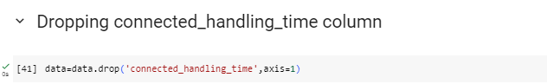

**Figure 4: Dropping unnecessary column**

(Source: Created and observed using Google Colab)

The ‘connected handling time’ column has been removed from the dataset, as this column comes with too many missing values. Using the drop function this data dropping function has been performed, the data become too short if this column will not removed.

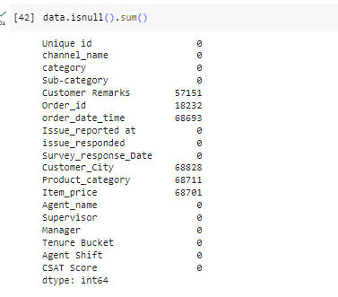

**Figure 5: Checking Null values in the dataset**

(Source: Created and observed using Google Colab)

Using the isnull() function the missing values have been identified from the dataset, where the Customer Remarks, Order_id, order_date_time, Customer_City, Product_category and Item_price has the missing values. This summary gives the completion of the data, provides a highlighter for the data column with missing values and that may need the data preprocessing during the data analysis.

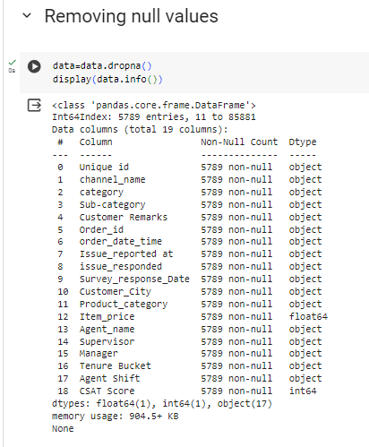

**Figure 6: Removing null values from the dataset**

(Source: Created and observed using Google Colab)

The above picture shows the rows of DataFrame data which and have null values (NaN) are eliminated. This operation is carried out using dropna() method which functions as a doing DataFrame without the missing rows. Later, the data variable is re-defined to incorporate this sanitized version by the method assign. Consequently, the display function (data.info()) is exploited to incorporate information on the data frame obtained after the missing values were removed. The info() method provides a summary containing number of non-null items for each column respectively together with their data types if they are non-null when evoked on a DataFrame. This output can be obtained by using a class called display() for a proper display of the result.

## Data visualization

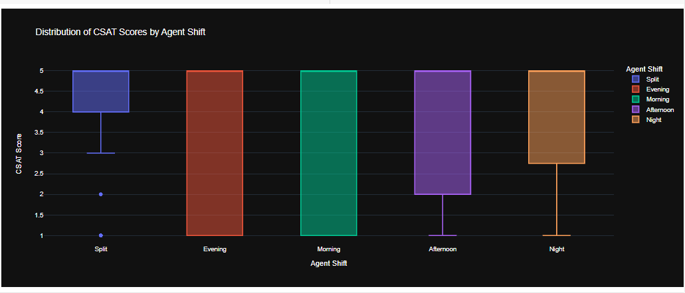

**Figure 7: Distribution of CSAT scores by agent shift interactively**

(Source: Created and observed using Google Colab)

The presented code draws the box plot over CSAT (Customer Satisfaction) scores by Plotly, which helps to visualize the distribution of shift schedules for customers. The visualization title is “Agent Shift”, briefly taken up the subject matter along with data analysis. The x-axis shows from different agent to different CSAT scores, while the y-axis show the amounts of CSAT. Every box plot in the graph is related to the distribution of a particular shift ratio related to one or more CSAT scores categories (Ramlogan *et al.* 2021). Observeably, the middle line of the box represents by the median CLASAT score, while the edges of the box show the interquartile range (IQR) and give the information on the distribution of scores. In addition, colour coding allows to distinct between different shifts variation of agents, which tends for visual comparison too. Interactivity of the visualization is realized with its providing users to hover over individual box plots to access complementary details about CSAT scores for certain agent shifts. Consequently, this visualization summarizes the whole experience with outlining the score distributions across the different shifts of agents and delves into the examination to discover the directions that the satisfaction in every agent shift follows.

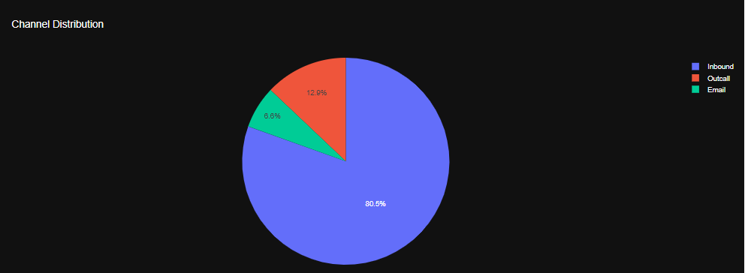

**Figure 8: Creating pie chart of channel distribution**

(Source: Created and observed using Google Colab)

The code makes use of Plotly to produce an interactive pie chart with data indicating the structure of the conversation channels received by customers. The title, "Channel Distribution," signifies a concise measure of the purpose, indicating that this chart showcases the distribution channel-wise. The three channels of communication are heading the graph. They are determined by the proportions of the their part in the pie chart. The visualization not only presents the segmentation by channel names but also produces hover events that individually show the channel name and proportion percentage. In summary, the figure provides a well organized and a basic overview of the level of the customer interactions dealt with by various channels.

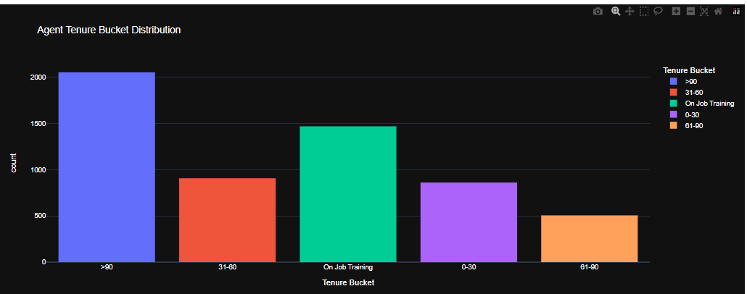

**Figure 9: Creating histogram of agent tenure bucket distribution**

(Source: Created and observed using Google Colab)

The above figure illustrates an interference histogram using Plotly, where the vertical axis demonstrates the popularity of agents based on the respective tenure buckets The ,"Agent Tenure Bucket Distribution," clearly announces the purpose of the histogram in which it deals with data related to agent tenure. The x-axis displays the different tenure buckets, which are arranged along the axis and categorize agents by their length of service. The histogram has several bars, each representing a group of tenures. The height of the bar corresponds to the number of agents that are present in a particular tenure. Scheme is such that histogram is color labeled as per the tenure buckets, with the consequence of better visual distinction. This visualization is intended to have an easy-read format where the font is in bright white on a dark background for heightened legibility. Overall, the graph is quite intuitive in terms of representation of distribution of tenure among various range swaths of tenure buckets.

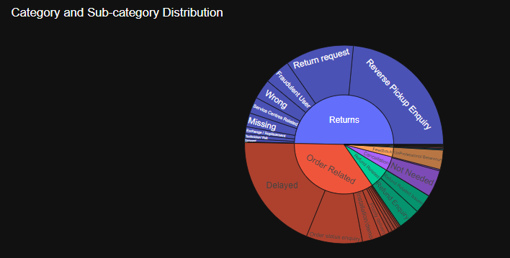

**Figure 10: Sunburst chart of category and sub-category distribution**

(Source: Created and observed using Google Colab)

The sunburst chart plotting matrix (Plotly) presents the data distribution with its main and sub-categories belonging to the dataset. Title, "Category and Sub-category Distribution," clear and straight, the chart is highlighted the sub-categorization in the structure of categories. The sunburst categories are organized, with the sub-categories inner and outermost rings representing each category. The sunburst chart is composed of the segments, each of which is related to a category or a sub-grouping, and the size of each segment indicates the number of occurrences that the data shares. To improve comprehension, the visualization uses high secrecy levels, in this case white priced font resting on a black background. To sum up, it is sunflower chart that provides a visualization that is simple and helpful for the interactive displaying the categories and sub-category tree structure within a dataset.

# Model training, testing, and evaluation

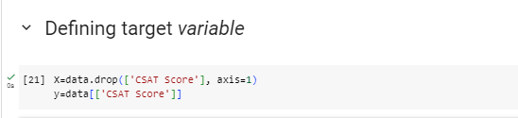

**Figure 11: Defining target variable**

(Source: Created and observed using Google Colab)

The target column ‘csat score’ has been assigned to the variable y and except tht all the other dataset variables are assigned to variable X.

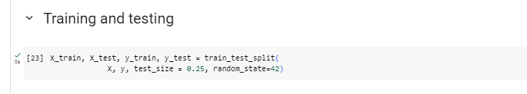

**Figure 12: Splitting data into train and test**

(Source: Created and observed using Google Colab)

The dataset has been splitted into train and test, further the models will be fitted into train data and prediction will be taken from the test dataset.

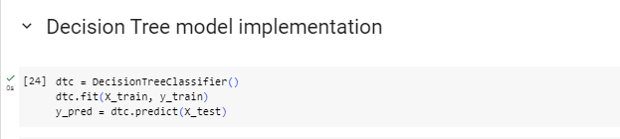

**Figure 13: Decision tree model implementation**

(Source: Created and observed using Google Colab)

The decision tree classifier model has been implemented on the train dataset, where the model renamed as dtc and that has been fitted on the train dataset and prediction has been performed from the test data.

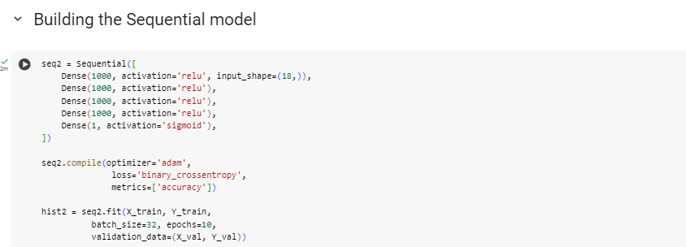

**Figure 14: Neural network model implementation**

(Source: Created and observed using Google Colab)

The above code comes with a Sequential model, from keras deep learning library, which is useful for many advanced models. The model involves three dense (fully connected) layers. The outer layer has got the ReLU activation function which accepts the input data with different shapes. As a Dropout layer with 0.5 dropout rate is inserted among the first and second dense layers preventing overfitting. The second thick layer is actually its own dense layer (32 neurons) with ReLU activation. The third one, that of the output layer, a single neuron without activation aggregation, usually is used for regression.

# Result and discussion

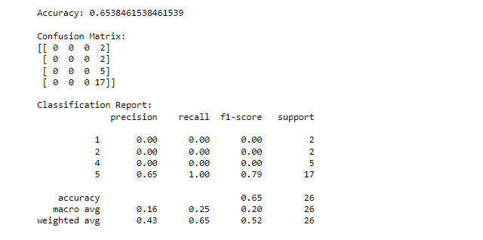

**Figure 15: Decision tree model classification report**

(Source: Created and observed using Google Colab)

This output visualizes the model’s output which displays several performance metrics, such as precision, recall, and F1-score, for five different classes (1 through 5) and the general score of overall accuracy. Model reaches a 65% accuracy score making it possible to evaluate the proportion of instances from all of the total instances that are classified correctly (Drukker *et al.* 2020). The level of precision, recall, and F1-score for each class differ with class 5 having the highest precision, recall and F1-score, this signify that is the highest class it is able to classify one class more than the others. Nevertheless, the preciseness, recall, and F1-score are on the low side in which this means that the model may have problem that it is not able to uniformly classify instances per every class.

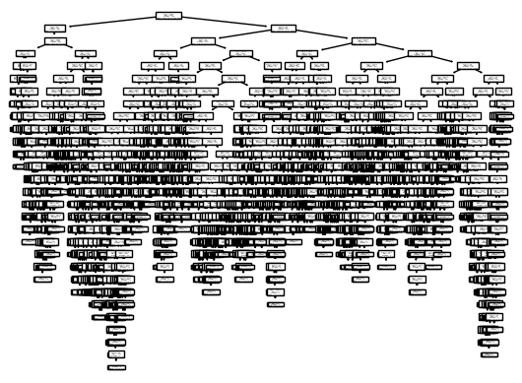

**Figure 16: Plotting the tree**

(Source: Created and observed using Google Colab)

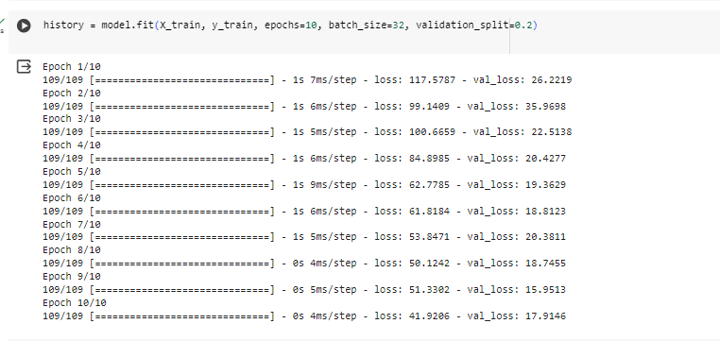

**Figure 17: Neural network model validation score**

(Source: Created and observed using Google Colab)

The output illustrates 10 epochs time the model after training a neural network. Being epoch-dependent, the MSE signifies how each epoch's loss, for the training set and the validation set is being reported. The losses at the early epochs are high which is natural, and then gradually decreases across epochs showing the improvement in the model performance as it learns from the training data (Rodríguez *et al.* 2021). While the model seems to overfit to the training data because of the fluctuations in loss values between epochs, the lack of convergence of training loss among epochs suggests that the model does not generalize well to unseen data. In general, operating conversationally reminds us of the iterative nature of the model's training by providing a performance summary.

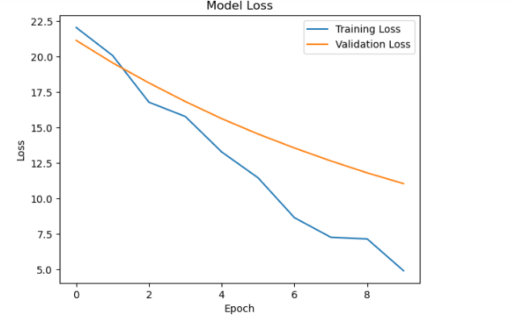

**Figure 18: Model loss curve**

(Source: Created and observed using Google Colab)

The plot shows the training and validation loss as counterparts with each epoch completed of the training process of a machine learning model (Baccour *et al.* 2022). An axis is x and is the epoch count. The other axis is y and it is the loss value which is normally MSE (the mean squared error) which measures the the difference between the predicted and actual values. Two lines are depicted: on the x-axis, plot the training loss and on the y-axis, plot the validation loss. The plot demonstrates that both training and validation losses vary with the number of epochs (successive iterations) used for learning by the model, supplying valuable information about its progress.

**Discussions:**

* High Dimensionality: When a dataset has a large number of features, it increases the complexity of the model and the risk of overfitting. Not all features may be informative for predicting the target variable (CSAT Score), and some may even be noise. Dimensionality reduction techniques such as feature selection or dimensionality reduction algorithms like PCA (Principal Component Analysis) can help mitigate this issue by focusing on the most relevant features.
* Imbalanced Classes: In datasets where one class of the target variable (in this case, CSAT Score) is significantly more prevalent than others, the model may become biased towards the majority class. As a result, it may perform poorly in predicting the minority classes. Techniques such as oversampling, undersampling, or using algorithms that are robust to class imbalance (e.g., weighted loss functions) can help address this issue.
* Unstructured Text Data: Text data in the "Customer Remarks" column poses a challenge because it requires specialized processing techniques. Simply treating it as categorical data may not capture the rich information it contains. NLP (Natural Language Processing) techniques such as tokenization, stemming, and sentiment analysis can help extract meaningful features from text data and incorporate them into the modeling process.
* Temporal Features: Time-related features such as "Issue_reported at" and "issue_responded" may contain valuable information about customer behavior and service response times. However, if these features are not properly encoded or utilized, the model may fail to capture important temporal patterns. Techniques such as time-series analysis or creating lag features to capture trends over time can help leverage the temporal aspect of the data.
* Quality of Labels: The accuracy of the CSAT Score labels is crucial for model training. If the labels are subjective, inconsistent, or noisy, the model's ability to learn meaningful patterns may be compromised. It's essential to validate the quality of the labels and potentially refine them through expert judgment or additional data collection efforts.
* Lack of Feature Engineering: Feature engineering involves transforming raw data into informative features that better represent the underlying patterns in the data. In the context of customer support data, feature engineering could involve creating new features based on customer demographics, agent performance metrics, or sentiment analysis of customer remarks. By incorporating domain knowledge and creativity, feature engineering can enhance the model's ability to capture relevant information.
* Model Selection and Hyperparameters: The choice of modeling algorithms and their hyperparameters significantly impacts model performance. For example, decision trees may struggle with high-dimensional data, while neural networks may require careful tuning of parameters such as learning rate and network architecture. Experimenting with different algorithms and hyperparameters through techniques like cross-validation and grid search can help identify the best-performing model configuration for the given dataset.

# Ethical discussion

## Data collection and privacy

The collection of data for this project on e-commerce customer service satisfaction is aimed at ensuring that data privacy issues are important and that they need to be at the top of the list of priorities during this work. As first measures of privacy protection the client's data collection and use only after granting explicit consent is essential so that good transparency and respect for users autonomy can be guaranteed (Braga-Neto 2020). Similarly, hiding or anonymizing in each information of personal identification details serves as a good shield against customers’ privacy.

Additionally, an all-encompassing data security architecture that will block the chances of inappropriate access or prevent breaches should be prioritized. As well as that, abiding by the GDPR or CCPA that are the significant laws lends itself to ethical data management processes, which in turn lead to the trust and accountability, in customers personal data within the eCommerce sector.

## Model development

Ethics considerations must be seen as a vital aspect in building machine learning model for customers’ satisfaction priorities in eCommerce, as these would enable fair and responsible use of technology. Last but not the least, impartiality is the main focus in the system and it should be aware of the customer categories and the training data will make a difference. Also, transparency in model development with revealing the constraints and evidence of how biases could occur in the same helps maintain faith and responsibility (Rezwan and Choi 2022). Consequently, conducting recurrent checks and auditing of the models accuracy to identify and address any biases or negative effects is also critical. Consequently, being client-oriented is critical and that client service should involve taking their privacy and security issues seriously through the modelling process. Finally, ethical standards for online customer service are established, it creates fairness, transparency, and overall trust.

# Conclusion, recommendation, and future work

Finally, the use of eCommerce machine learning models to smooth down customers' service satisfaction creates a context wherein there are a lot of prospects and challenges in respecting the users experience and company efficiency. The venture was able to get to the bottom of different data mining techniques to analyze the customers' actions and the level of satisfaction. It is also necessary, though, to factor in privacy issues of data and model development because it is difficult for everyone to trust in decisions made by machine learning models.

* In addition to this, machine learning algorithms should be developed in a way to make predictions more accurate and when these algorithms predict an outcome they should be understandable by any person.
* Incorporating real-time data feeds anticipatory and intelligent customer service solutions are being integrated in a manner that is dynamic and adaptive.
* The lapsing of the continuous feedbacks and checkups of the performance to adjust and address future of the customers' needs and business changes and other market dynamics
* Construction of the core model based on expert knowledge and further improves its efficiency through the integration of our specialized skills.
* Exploration of developed solutions that bring in natural language processing (NLP) and sentiment analysis that provide deeper insights into customer attitudes and preferences.

Through addressing the recommendations, it can prevent the companies being engaged in eCommerce from sustainable failure and improving performance at the customer service and another successful practice.

# 

# References

Alonso, J.M., 2020. Teaching explainable artificial intelligence to high school students. *International Journal of Computational Intelligence Systems*, *13*(1), pp.974-987.

Baccour, E., Mhaisen, N., Abdellatif, A.A., Erbad, A., Mohamed, A., Hamdi, M. and Guizani, M., 2022. Pervasive AI for IoT applications: A survey on resource-efficient distributed artificial intelligence. *IEEE Communications Surveys & Tutorials*, *24*(4), pp.2366-2418.

Braga-Neto, U., 2020. *Fundamentals of pattern recognition and machine learning* (pp. 1-286). Berlin/Heidelberg, Germany: Springer.

Drukker, L., Noble, J.A. and Papageorghiou, A.T., 2020. Introduction to artificial intelligence in ultrasound imaging in obstetrics and gynecology. *Ultrasound in Obstetrics & Gynecology*, *56*(4), pp.498-505.

Farina, E., Nabhen, J.J., Dacoregio, M.I., Batalini, F. and Moraes, F.Y., 2022. An overview of artificial intelligence in oncology. *Future Science OA*, *8*(4), p.FSO787.

Hoshimovna, S.S., Abdurakhimovna, R.D. and Khasanboevna, M.S., 2023. Fundamentals Of Creating An Electronic Encyclopedic Dictionary Of Linguistic Terms. *Journal of Positive School Psychology*, *7*(8), pp.160-166.

Lisovenko, A., Kriukova, M., Absalyamova, L., Chukhrii, I., Korchakova, N. and Androsovych, K., 2022. Neuropsychological Fundamentals of Envy. *BRAIN. Broad Research in Artificial Intelligence and Neuroscience*, *13*(1), pp.158-172.

Raffort, J., Adam, C., Carrier, M. and Lareyre, F., 2020. Fundamentals in artificial intelligence for vascular surgeons. *Annals of vascular surgery*, *65*, pp.254-260.

Ramlogan, R.R., Chuan, A. and Mariano, E.R., 2021. Contemporary training methods in regional anaesthesia: fundamentals and innovations. *Anaesthesia*, *76*, pp.53-64.

Rezwan, S. and Choi, W., 2022. Artificial intelligence approaches for UAV navigation: Recent advances and future challenges. *IEEE access*, *10*, pp.26320-26339.

Rodríguez-García, J.D., Moreno-León, J., Román-González, M. and Robles, G., 2021, March. Evaluation of an online intervention to teach artificial intelligence with learningml to 10-16-year-old students. In *Proceedings of the 52nd ACM technical symposium on computer science education* (pp. 177-183).

Thakur, A. and Konde, A., 2021. Fundamentals of neural networks. *International Journal for Research in Applied Science and Engineering Technology*, *9*(VIII), pp.407-426.

Wang, J., Tang, W., Han, Y., Jin, S., Li, X., Wen, C.K., Cheng, Q. and Cui, T.J., 2021. Interplay between RIS and AI in wireless communications: Fundamentals, architectures, applications, and open research problems. *IEEE Journal on Selected Areas in Communications*, *39*(8), pp.2271-2288.

Wang, Y., Su, Z., Zhang, N., Xing, R., Liu, D., Luan, T.H. and Shen, X., 2022. A survey on metaverse: Fundamentals, security, and privacy. *IEEE Communications Surveys & Tutorials*, *25*(1), pp.319-352.